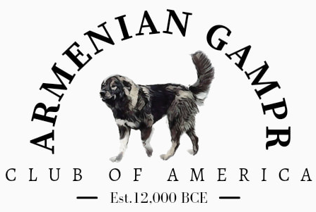
ARMENIAN GAMPR PUPPY WEIGHT CHART
SIRE: _____________________________________ DAM: _____________________________________ MALES: __________ FEMALES: _________ DOA: _________ DOB: ____________________

Puppy | Gender | Coat Color | Birth  Weight | Day 7  Weight | Day 14  Weight | Day 21  Weight | Day 28  Weight | Day 35  Weight | Day 42  Weight | Day 49  Weight | Day 56  Weight | Day 63  Weight | Notes

